PROFIT, LOSS
Pearson Edexcel - Thursday 8 November 2018 - Paper 2 (Calculator) Higher Tier
1.
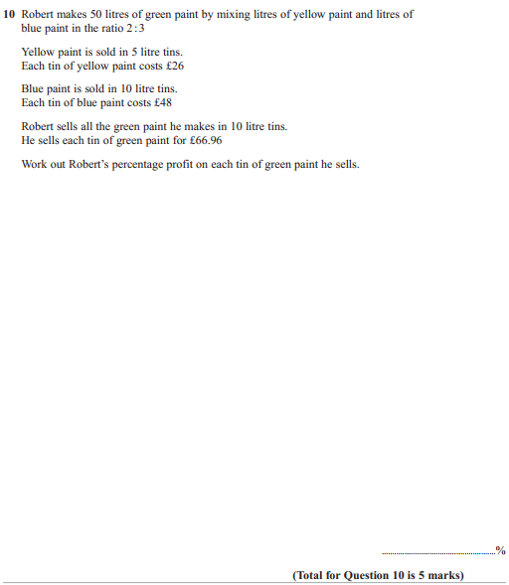

Pearson Edexcel - Thursday 24 May 2018 - Paper 1 (Non-Calculator) Higher Tier
2.

Pearson Edexcel - Tuesday 12 June 2018 - Paper 3 (Calculator) Higher Tier
3.
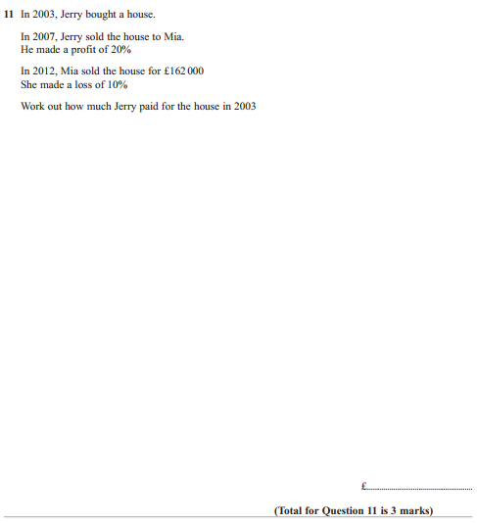

Pearson Edexcel - Monday 6 November 2017 - Paper 2 (Calculator) Higher Tier
4.
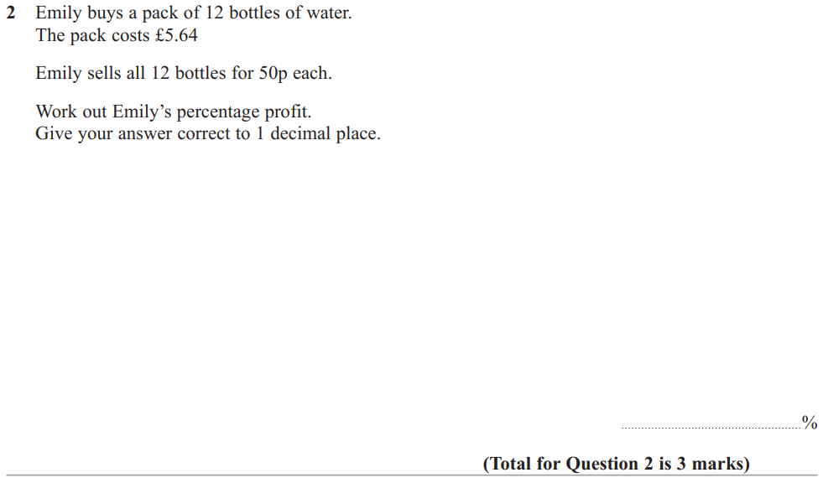

Pearson Edexcel - Specimen Papers Set 2 - Paper 1 (Non-Calculator) Higher Tier
5.
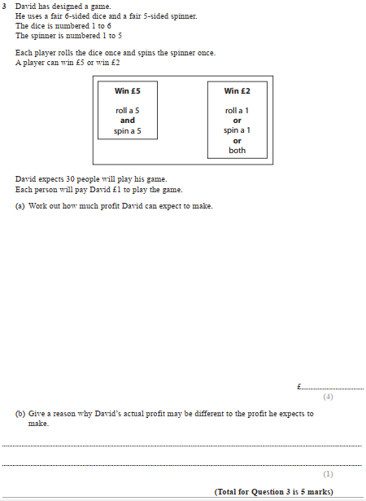

OCR GSCE – Tuesday 3 November 2020 – Paper 4 (Calculator) Higher Tier
6.
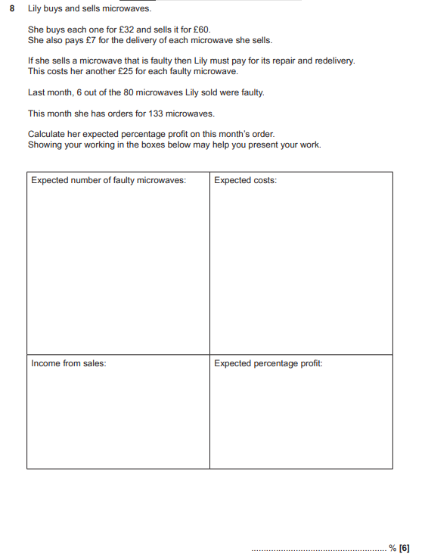

OCR GSCE – Tuesday 6 November 2018 – Paper 4 (Calculator) Higher Tier
7.
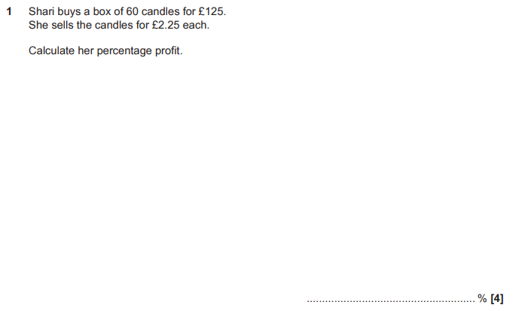
OCR GSCE – Sample Papers – Paper 4 (Calculator) Higher Tier
8.
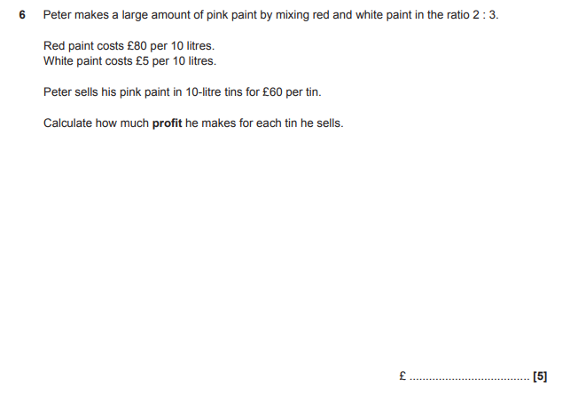
OCR GSCE – Sample Papers – Paper 5 (Non - Calculator) Higher Tier
9.
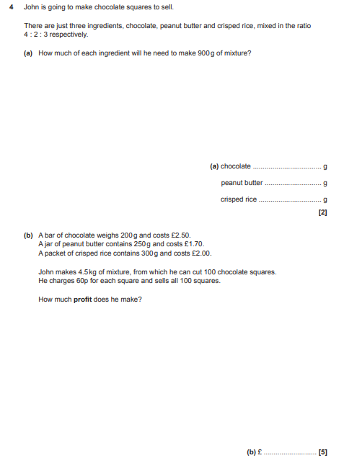

AQA GSCE – Thursday 8 June 2017 – Paper 2 (Calculator) Higher Tier
10.
